13.25: a) 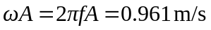. 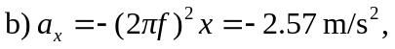
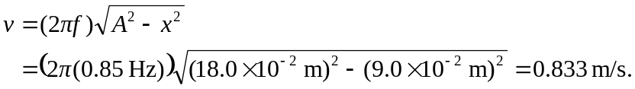
c) The fraction of one period is 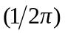arcsin 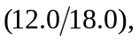 and so the time is 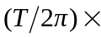arcsin 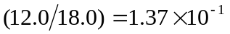s. Note that this is also arcsin 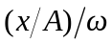.
d) The conservation of energy equation can be written 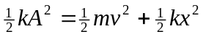. We are given amplitude, frequency in Hz, and various values of . We could calculate velocity from this information if we use the relationship 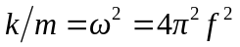and rewrite the conservation equation as 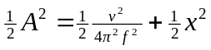. Using energy principles is generally a good approach when we are dealing with velocities and positions as opposed to accelerations and time when using dynamics is often easier.

